Lab 6: Network Monitoring with SDN

# Objectives

* Learn developing SDN traffic monitoring applications.
* Gain real time traffic measurement experience.
* Manage flows in real-time based on traffic measurement.

# Equipment

* Computer with Internet Connectivity.

# References

* RYU programming guide: <https://osrg.github.io/ryu-book/en/html/>

# Experiments

* 1. Go through the traffic monitoring example provided by RYU website: <https://osrg.github.io/ryu-book/en/html/traffic_monitor.html>
  2. Create the following topology using the topology file provided on NYU Classes to create 5 switches and 3 hosts. The topology .py file also includes a costumed command: “runTraffic” to use in the Mininet prompt. This command generates UDP traffic among H1, H2 and H3 for 10 mins.

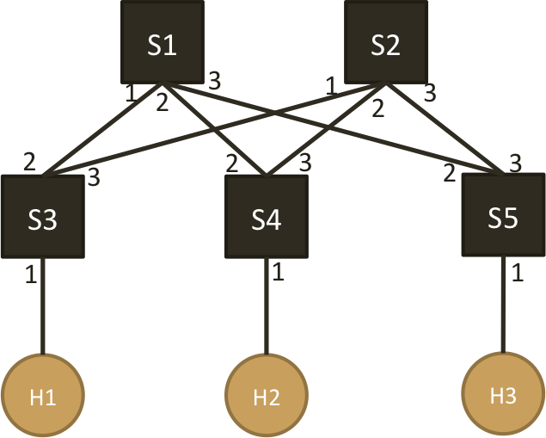

* 1. Write two controllers to,
     1. Controller 1: When a new flow arrives, always manage the flow to follow the paths as instructed below,   
         H1 🡺 H2: S3 – S1 – S4   
         H1 🡺 H3: S3 – S1 – S5  
         H2 🡺 H3: S4 – S1 – S5  
         Measure (every 5 or 10 seconds) the traffic rate (in bps) of each link for 10 mins and draw a figure of ( time vs. traffic rate ) for each link
     2. Controller 2: Use the measured traffic (every 5 or 10 seconds) to manage flows so that all the links in the network is as evenly loaded as possible. Flow management can be done through either arranging new arriving flow’s path or re-locating existing flows. Draw a figure of ( time vs. traffic rate ) for each link.
  2. Start the controller, and run the “runTraffic” command in Mininet prompt to monitor the traffic and manage flows for 10 mins.

# Reports

1. Explain your approach used in Controller 2 to evenly distribute the traffic onto different links.
2. Submit your controller codes for both controller 1 and controller 2
3. Figures of ( Time vs. Traffic Rate (bps) ) on each link over 10 mins from both controller 1 and controller 2

**We have zero tolerance to forged or fabricated data!!** A single piece of forged/fabricated data would bring the total score down to zero.